Relational Databases with MySQL Week 4 Coding Assignment

**Points possible:** 70

|  |  |  |
| --- | --- | --- |
| Category | Criteria | % of Grade |
| Functionality | Does the code work? | 25 |
| Organization | Is the code clean and organized? Proper use of white space, syntax, and consistency are utilized. Names and comments are concise and clear. | 25 |
| Creativity | Student solved the problems presented in the assignment using creativity and out of the box thinking. | 25 |
| Completeness | All requirements of the assignment are complete. | 25 |

**Instructions:** Using a text editor of your choice, write the queries that accomplishes the objectives listed below. Take screenshots of the queries and results and paste them in this document where instructed below. Create a new repository on GitHub for this week’s assignments and push this document, with your Java project code, to the repository. Lastly, in the Learning Management System, click the “Add Submission” button and paste the URL to your GitHub repository.

**Coding Steps:**

Write 5 stored procedures for the employees database.

Write a description of what each stored procedure does and how to use it.

Procedures should use constructs you learned about from your research assignment and be more than just queries.

**Screenshots:**

**The upcoming_birthdays procedure allows you to search your department for all upcoming birthdays in the next 7 days. Simply call the procedure with your department number and see all employees with a birthday that week.**

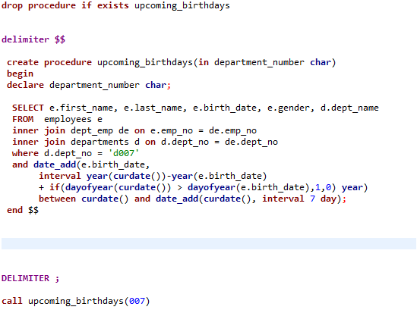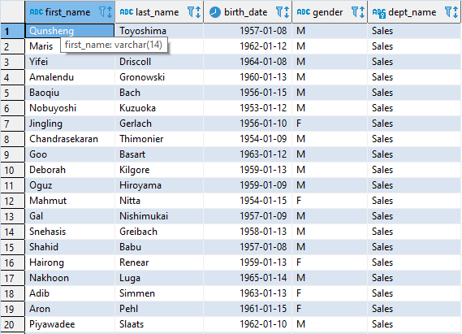

**The find_average_salary_in_dept lets you fin the average salary in any department by entering the department number when you call it**

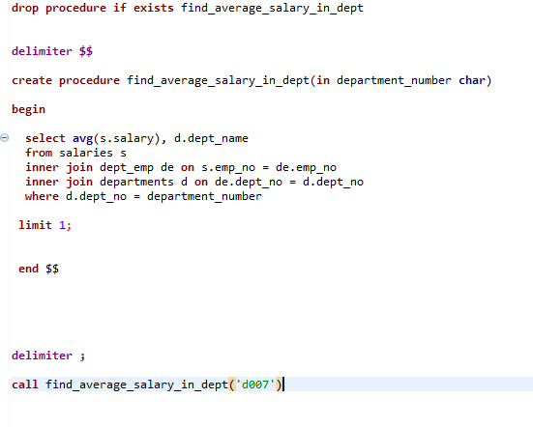

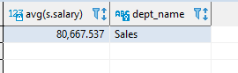

**The emp_of_type procedure lets you know if the employee is a veteran, seasoned, or a newby based on how long he has worked for the company by just entering his employee id**

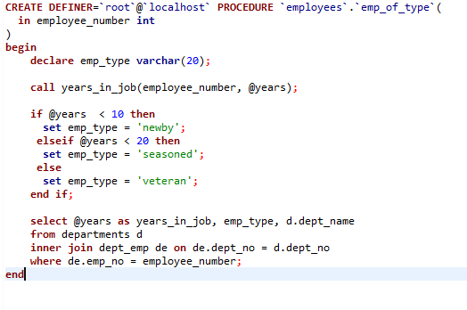



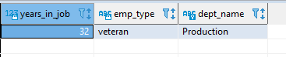

**The years_in_job procedure allows you to find the years an employee has been on the job by just entering his employee number**

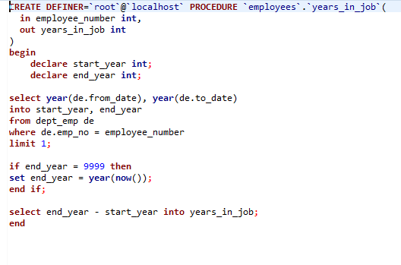

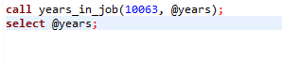

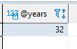

**The find_how_many_employee_by_age procedure allows you to put in a date and see how many employees by each title are a certain age or older**

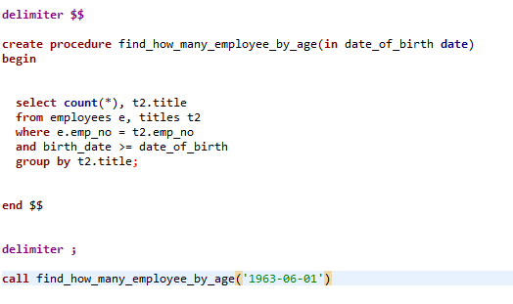

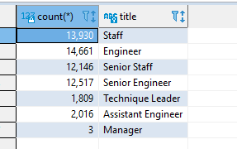

**URL to GitHub Repository:**

**https://github.com/ale2362189/stored_procedures.git**